PLZZA SALES SQL QUERIES

**A.KPl’s**

**1.total Revenue:**

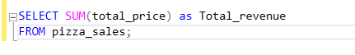

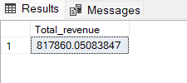

**2.Average Order Value**



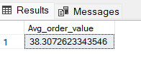

**3.Total pizzas sold**



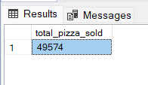

**4.Total Orders**



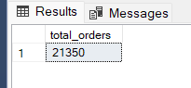

**5.Average pizzas per Order**



***Output:***

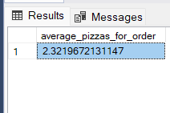

**B. Daily Trend for Total Orders**

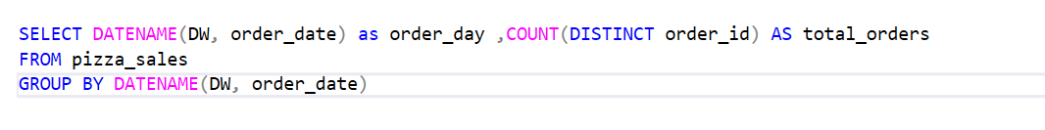

***Output:***

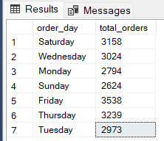

**C. Monthly Trend for Orders**

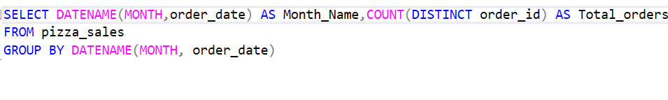

***Output:***

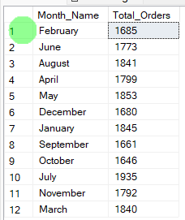

**D. % of Sales by Pizza Category**

**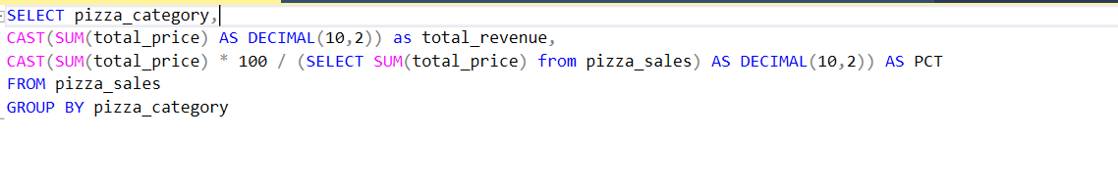*Output:***

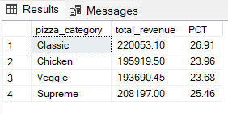

**E. % of Sales by Pizza Size**

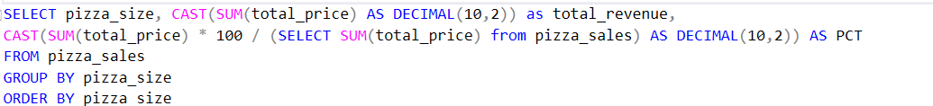

***Output:***

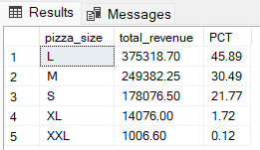

**F. Total Pizzas Sold by Pizza Category**

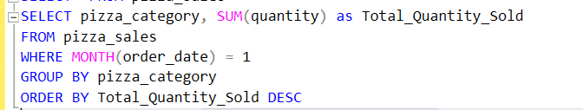

***Output***

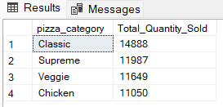

**G. Top 5 Pizzas by Revenue**

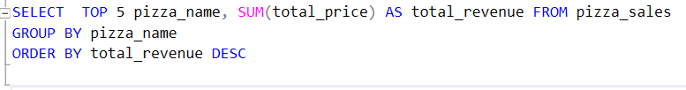

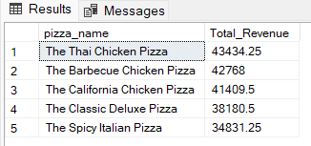

**H. Bottom 5 Pizzas by Revenue**

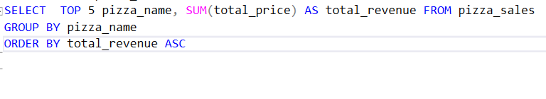

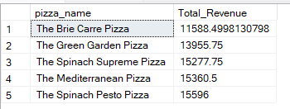

**I. Top 5 Pizzas by Quantity**

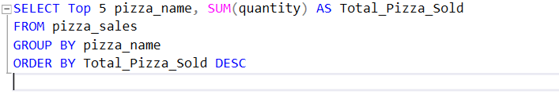

***Output***

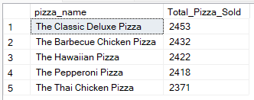

**J. Bottom 5 Pizzas by Quantity**

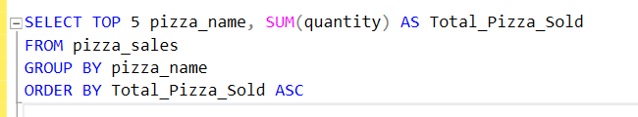

***Output***

